**Story Board- Search a podcast**

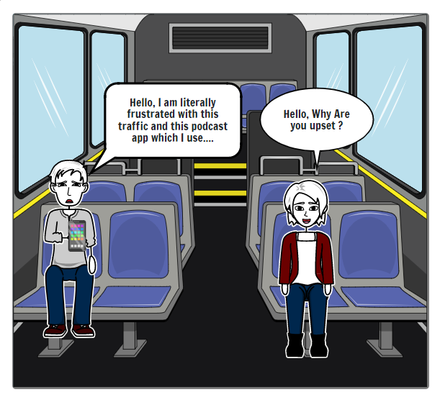

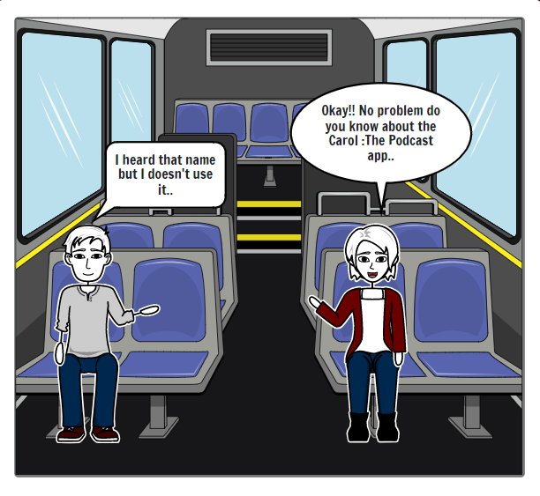

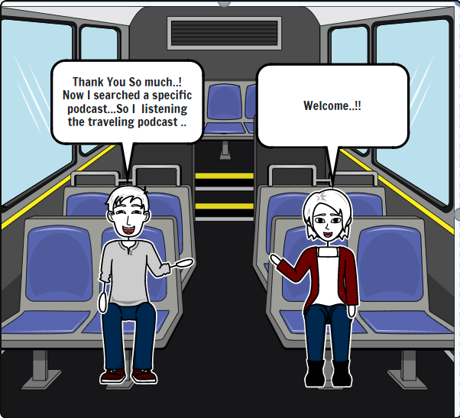

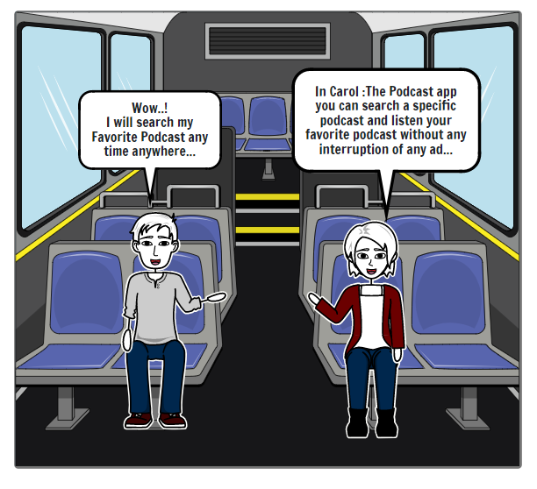

**Story Description –**

**Once a boy was traveling by bus. A girl is sitting on the bench next to him. The girl sees the boy very sad so she asks him why are you sad? He says I am literally frustrated with this traffic and this podcast app. She tells him it's no problem at all. Do you know about the Carol app? It is a podcast app. The boy says I have heard the name but I am not using it. As the boy has not used that app, she tells him all the information about that app. You can search for specific podcasts within the app. You can listen to your favorite podcast without any ads. The boy gets happy hearing all this and says I can listen to my favorite podcast anytime anywhere it's great. Thank you very much for giving me this information.**